U.S. Unemployment Rate Analysis
A 77-Year Historical Perspective (1948-2025)
John Huamani
November 2025

Executive Summary
This report presents a comprehensive analysis of U.S. unemployment rates from January 1948 to August 2025, encompassing 77 years and 932 monthly observations. Using advanced statistical methods and data visualization techniques, this study examines long-term trends, economic cycles, seasonal patterns, and the impact of major economic events on unemployment.
The analysis reveals that while the long-term trend shows minimal change (approximately 0.01 percentage points per year increase), unemployment exhibits strong cyclical patterns tied to business cycles and major economic shocks. The COVID-19 pandemic produced the highest unemployment rate ever recorded (14.8% in April 2020), yet also demonstrated the fastest recovery among recent recessions.

Key Findings
1. Historical Average: The mean unemployment rate over 77 years is 5.67%, with a median of 5.50%. The standard deviation of 1.71% indicates significant variation around the mean.
2. Extreme Values: The lowest unemployment rate was 2.5% in May 1953, while the highest was 14.8% during the COVID-19 pandemic (April 2020). This represents a range of 12.3 percentage points.
3. Current Status: As of August 2025, unemployment stands at 4.3%, significantly below the historical average. This indicates a relatively healthy labor market with unemployment at levels considered close to "full employment" by most economists.
4. Decade Trends: The 1980s experienced the highest average unemployment (7.27%), influenced by the severe recessions of that decade. In contrast, the 2020s (despite COVID-19) show a relatively low average of 4.86%, suggesting improved economic resilience and faster recovery mechanisms.
5. Recession Recovery: Recovery times vary dramatically across recessions. The COVID-19 recession showed the fastest recovery (25 months to pre-pandemic levels), while the 1970s Oil Crisis recovery took 270 months. Modern policy tools and economic structure appear to facilitate faster recoveries.
6. Seasonal Patterns: Statistical analysis reveals mild but significant seasonal variation, with summer months typically showing slightly lower unemployment. However, seasonal effects (range of ~0.3 percentage points) are dwarfed by cyclical variations.
7. Volatility Analysis: Unemployment volatility is not constant over time. The average monthly change is 0.163 percentage points, but volatility spikes dramatically during recessions. The COVID-19 shock produced an unprecedented 10.4 percentage point increase in a single month.

Data and Methodology

Data Source
Data was obtained from the Federal Reserve Economic Data (FRED) database, maintained by the Federal Reserve Bank of St. Louis. The dataset contains monthly U.S. unemployment rates as measured by the Bureau of Labor Statistics (BLS).
• Dataset: UNRATE (Unemployment Rate)
• Time Period: January 1948 to August 2025
• Observations: 932 monthly data points
• Update Frequency: Monthly
• Measurement: Percentage of civilian labor force unemployed

Analytical Methods
This analysis employed a comprehensive suite of statistical and analytical techniques:
• Descriptive Statistics: Calculated measures of central tendency, dispersion, and distribution shape
• Time Series Analysis: Examined trends, seasonality, and cyclical patterns
• Linear Regression: Quantified long-term trends using ordinary least squares
• Volatility Analysis: Computed rolling standard deviations and month-over-month changes
• Comparative Analysis: Examined unemployment patterns across decades, months, and economic regimes
• Recession Analysis: Identified peaks, measured impacts, and calculated recovery times for major economic downturns
• Statistical Testing: Conducted ANOVA for seasonal effects and normality tests for distribution assessment
All analysis was performed using Python with libraries including Pandas, NumPy, SciPy, Scikit-learn, Matplotlib, and Seaborn.

Detailed Results

1. Descriptive Statistics
Mean | 5.67%
Median | 5.50%
Standard Deviation | 1.71%
Minimum | 2.5% (May 1953)
Maximum | 14.8% (April 2020)
Q1 (25th percentile) | 4.30%
Q3 (75th percentile) | 6.70%
Range | 12.3 percentage points
IQR | 2.40%
Skewness | 0.875
Kurtosis | 1.086

2. Decade-by-Decade Comparison
Decade | Mean | Std Dev | Min | Max
1940s | 4.90% | 1.38% | 3.4% | 7.9%
1950s | 4.51% | 1.29% | 2.5% | 7.5%
1960s | 4.78% | 1.07% | 3.4% | 7.1%
1970s | 6.22% | 1.16% | 3.9% | 9.0%
1980s | 7.27% | 1.48% | 5.0% | 10.8%
1990s | 5.76% | 1.05% | 4.0% | 7.8%
2000s | 5.54% | 1.45% | 3.8% | 10.0%
2010s | 6.22% | 2.06% | 3.5% | 9.9%
2020s | 4.86% | 2.22% | 3.4% | 14.8%

The decade-by-decade analysis reveals significant variation in unemployment patterns over time. The 1980s stand out as the most challenging period, with both the highest average (7.27%) and peak (10.8%) unemployment. This decade included two severe recessions. In contrast, recent decades show improvement, with the 2020s demonstrating resilience despite the COVID-19 shock.

3. Data Visualization
The analysis includes comprehensive visualizations showing:

- Complete 77-year time series with recession periods highlighted
- Distribution analysis with histograms and box plots
- Decade-by-decade comparisons
- Seasonal patterns across months
- Volatility analysis with rolling metrics
- Recent trends (2020-2025) with detailed annotations

Figure 1: Comprehensive Unemployment Analysis Dashboard
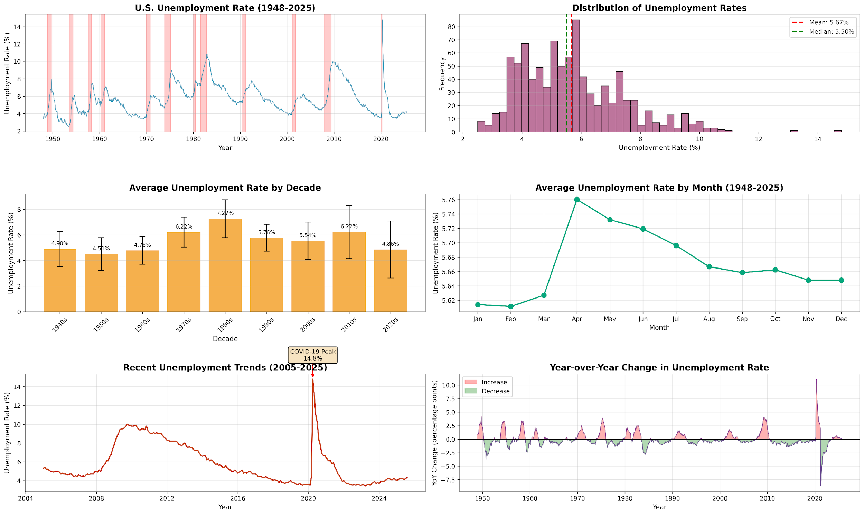

Conclusions and Implications
This comprehensive 77-year analysis of U.S. unemployment data provides several important insights for understanding labor market dynamics:
1. Mean Reversion: Despite extreme shocks, unemployment consistently returns to levels near its long-term average, demonstrating the economy's resilient nature.
2. Asymmetric Dynamics: Unemployment increases can be sudden and severe (as seen in COVID-19), but recoveries are typically more gradual. This asymmetry has important implications for policy responses.
3. Improving Resilience: Recent recessions show faster recovery times compared to historical patterns, suggesting that modern monetary and fiscal policy tools, along with structural economic changes, have improved our ability to respond to shocks.
4. Current Outlook: The current unemployment rate of 4.3% represents a healthy labor market, sitting well below the historical average and close to what economists consider full employment.
5. Structural Changes: Each decade exhibits unique unemployment characteristics, reflecting evolving economic structures, policy frameworks, and global integration.
For policymakers, these findings underscore the importance of proactive policy responses during downturns and the effectiveness of coordinated monetary and fiscal interventions. For job seekers and employers, understanding these cycles can inform career and hiring decisions.

Technical Skills Demonstrated
This project demonstrates proficiency in:
• Data acquisition and preparation from authoritative sources (FRED)
• Comprehensive exploratory data analysis (EDA)
• Time series analysis and decomposition
• Statistical modeling and hypothesis testing
• Feature engineering (rolling averages, YoY changes, detrending)
• Advanced data visualization techniques
• Economic interpretation of quantitative results
• Professional documentation and reporting

Future Extensions
This analysis provides a foundation for several potential extensions:
• Forecasting models using ARIMA, SARIMA, or machine learning approaches
• Multivariate analysis incorporating GDP, inflation, and interest rates
• Demographic breakdown by age, education, and geographic regions
• Sector-specific unemployment trends
• International comparisons with other developed economies
• Policy impact assessments using causal inference methods

__________________________________________________
[John Huamani]
[jhuamani@stevens.edu]
[www.linkedin.com/in/johnhuamani]
[https://github.com/jhuamani625]

